Statistics: Analysis on Superstore retail dataset
Author: Rashpinder Kaur Chahal
Database Name: SampleSuperstore
Library: Project

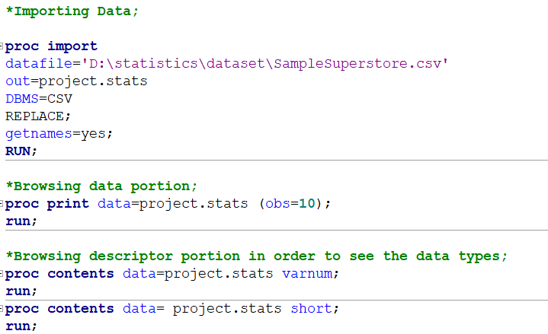

Categorical Univariate analysis
Categorical variables: (Frequency table, bar chart, pie chart)

Category (It is analysed to see which area of supplies is more sold)
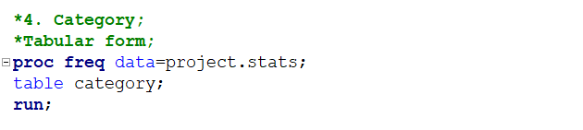
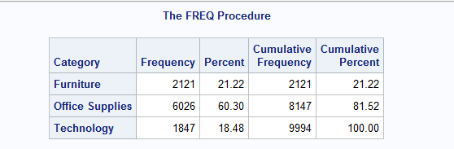

Office supplies are most frequently bought out of all categories while furniture and technology supplies are approximately equal.

The analysis focuses on the distribution of the variable "Category" within the dataset.
The data reveals a total of 9994 observations,
Furniture -2121 ie:21.22%
Office Supplies-6060 ie: 60.30%
Technology-1847 ie: 18.48%

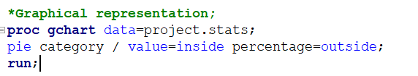
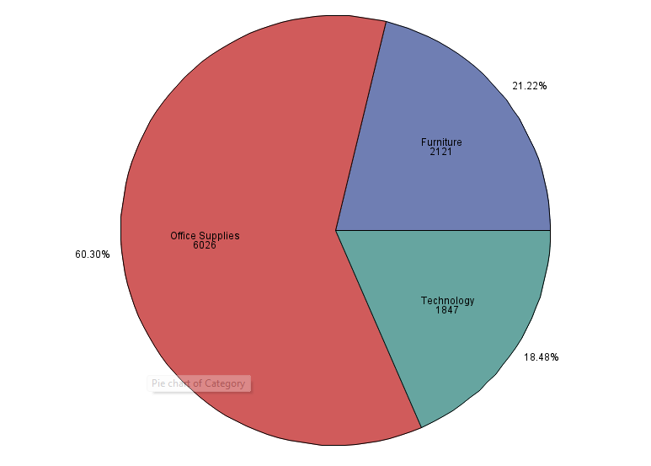

Region
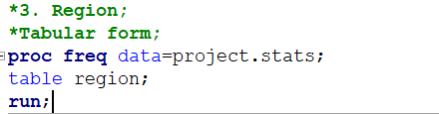
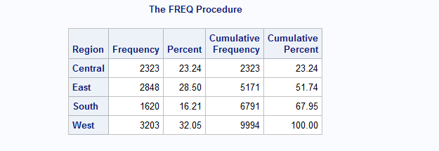

The analysis focuses on the distribution of the variable "Region" within the dataset.
The data reveals a total of 9994 observations,
Central -2323 ie:23.24%
East-2848 ie: 28.50%
South-1620 ie: 16.21%
West-3203 i.e., 32.05%

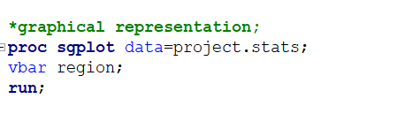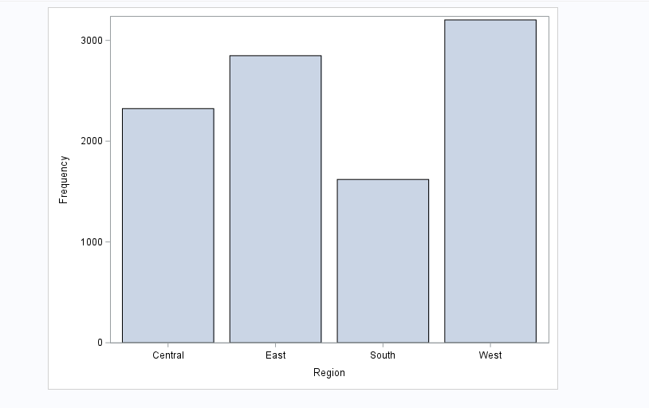

South region has least frequency.

Segment
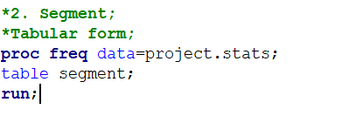
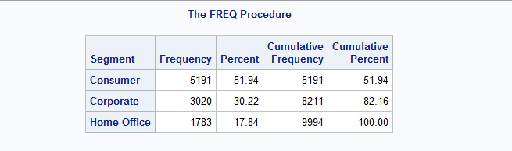
The analysis focuses on the distribution of the variable "Segment" within the dataset.
The data reveals a total of 9994 observations,
Consumer -5191 ie:51.94%
Corporate-3020 ie: 30.22%
Home office-1783 ie: 17.84%
Consumer portion have most frequency.

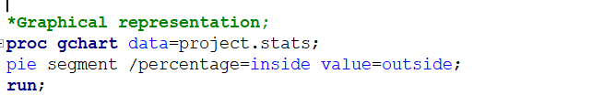
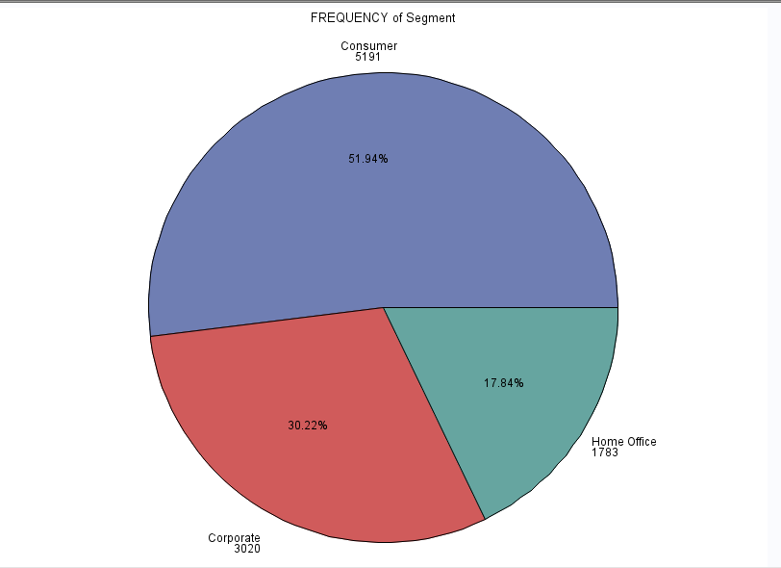

Sub_Category
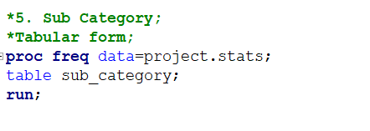
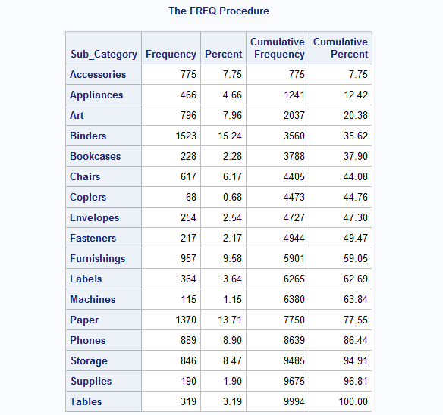


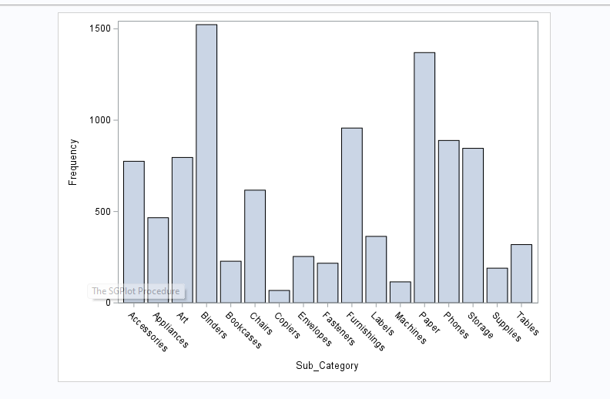

Binders and paper have max frequency whereas copiers have least.

Ship_Mode
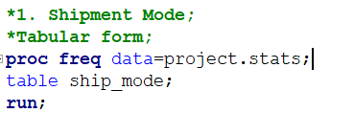

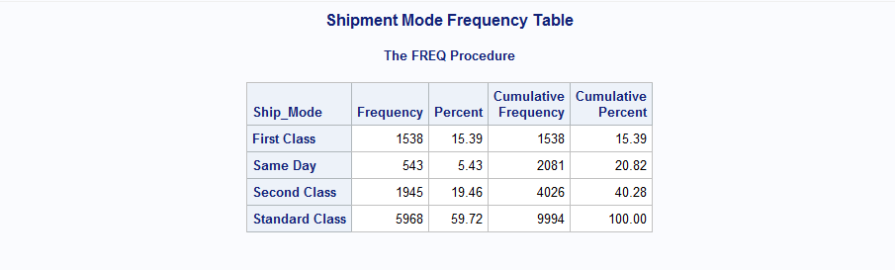

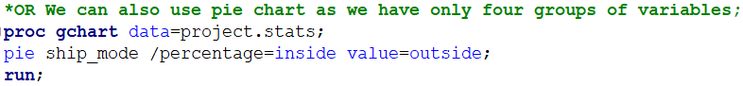
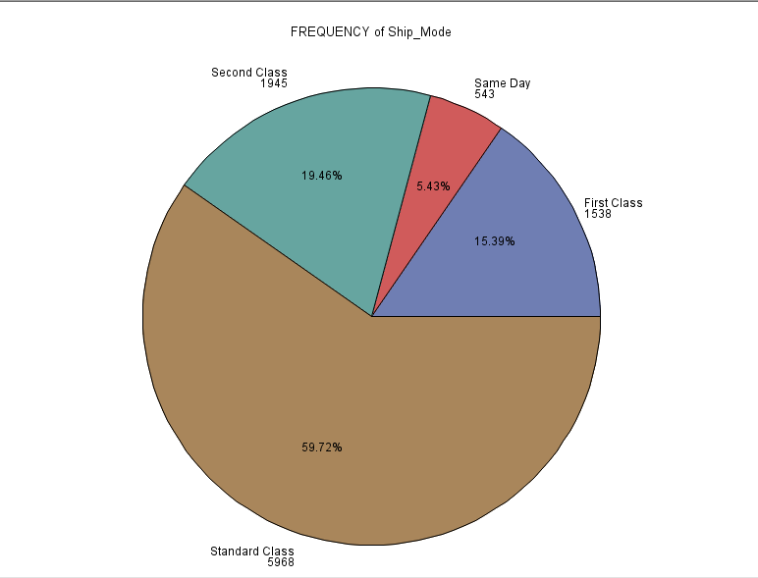

Most of the shipments are through standard class whereas same day shipment frequency is least.

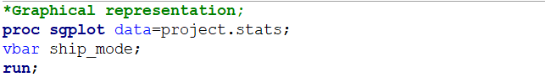
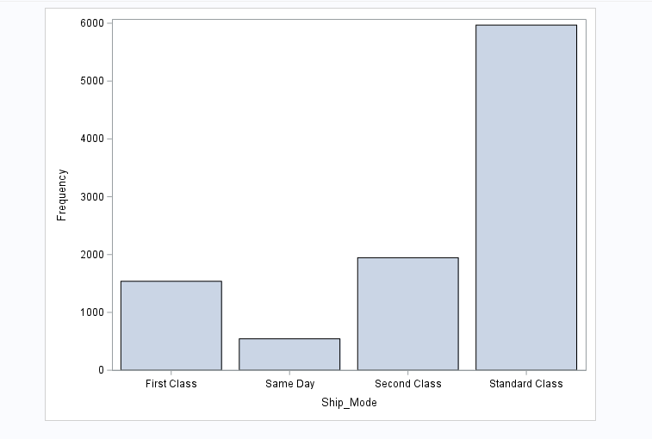

The analysis focuses on the distribution of the variable "Shipment mode" within the
dataset.
The data reveals a total of 9994 observations,
First Class -1538 ie:15.39%
Same Day-543 ie: 5.43%
Second Class-1945 ie: 19.46%
Standard Class-5968 ie: 59.72%

Numerical Univariate Analysis
(5 number summary, var, SD, Range, IQR, histogram, density curve, box plot)

- Profit
- Sales
- Discount
- quantity

Profit
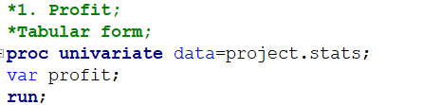
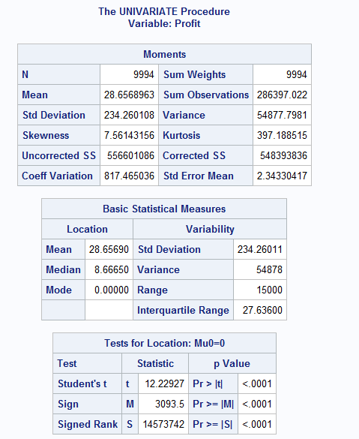
The values of mean and median have huge difference, mean is 28.65 whereas median is 8.6 that means we do not have a normal distribution of the values of profit variable.
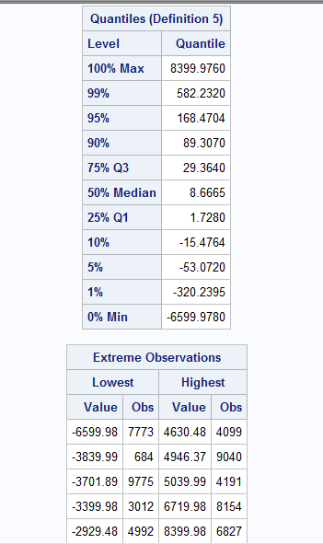

Total observation are 9994 with average profit is 28.65 for all the observations, standard deviation is 234.26 that means the spread ness of data, we have positive skewness value i.e., right skewed, value is 7.56 Similarly, kurtosis is 397.18

Range is 13 i.e., max-min =15000

The value of Q1=1.7280 (75% data have profit value more than 1.7280 and 25% data have less than 1.7280)
Similarly, Q3=29.36 (25% data have profit more than 29.36 and 75% data for quantity is less than 29.36)
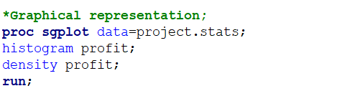
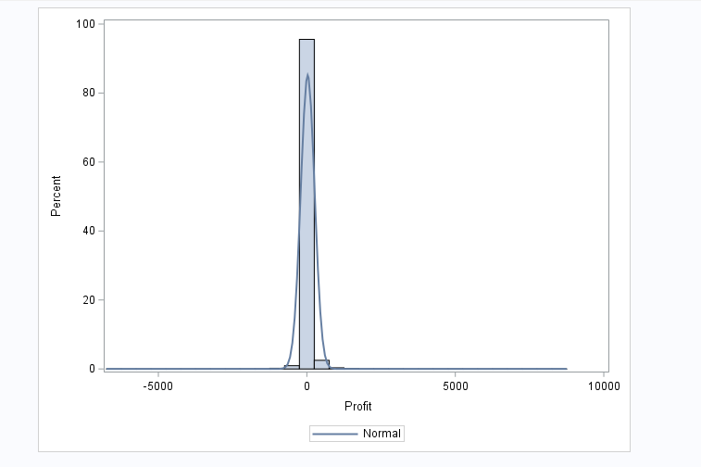

We have a positive skewness for the data which means there are outliers in the right side of the data and that is why mean is shifted to the right side of the data.
We have high value of kurtosis i.e. a sharp peak which predicts that we have extreme values in our data.

Quantity
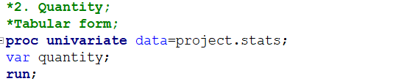
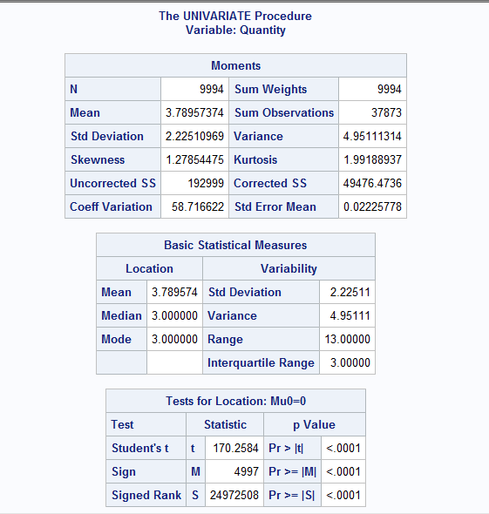

Kurtosis is between the threshold value i.e. (-3,3), so there is no sharp peak in the graph and this indicates that there are fewer potential outliers.
Skewness is positive which indicates that the outliers exist in the right side of the data.
Mean and median values are not approximately similar which indicates that the value of mean is affected by the outliers and that the data distribution is not normal.
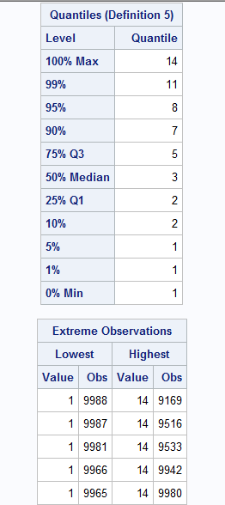

Total observation is 9994 with average quantity is 3.7895 for all the observations, standard deviation is 2.225 that means the spread ness of data, we have positive skewness value
i.e., right skewed, value is 1.2785
Similarly, kurtosis is 1.991 which is between threshold (-3,3)
Range is 13 i.e., max-min =14-1=13
The value of Q1=2 (75% data have quantity value more than 2 and 25% data have less than 2)
Similarly, Q3=5 (25% data for quantity is more than 5 and 75% data for quantity is less than 5)

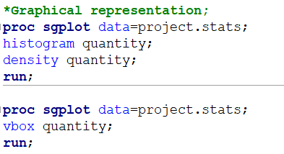

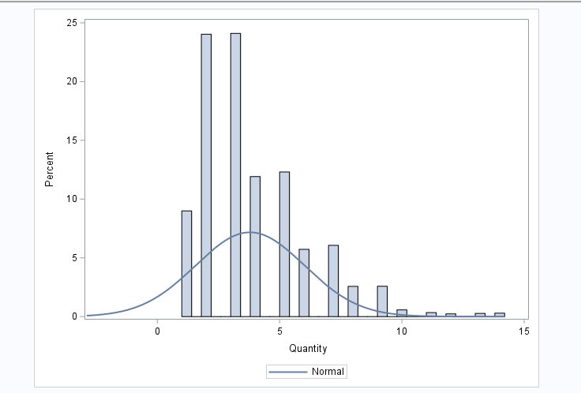

Not normal, right skewed, outliers in right side

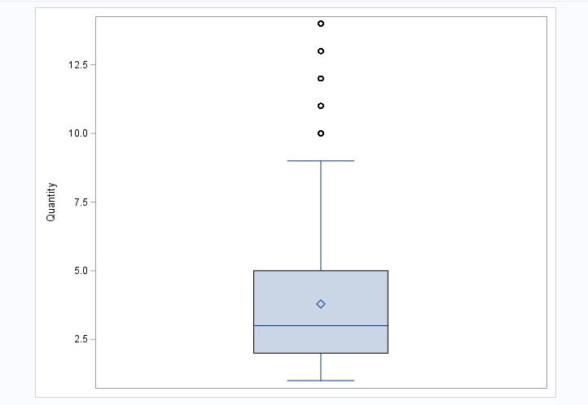

Mean and median does not align, so not a normal distribution of data, outliers exist that is why mean is affected and is shifted to the right of the data.

Sales
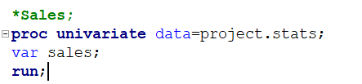
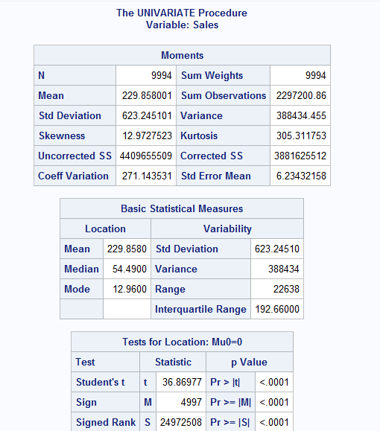
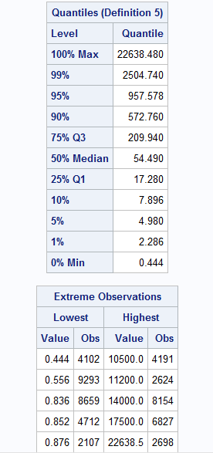

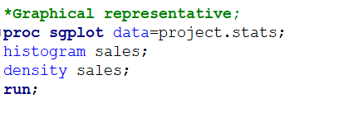
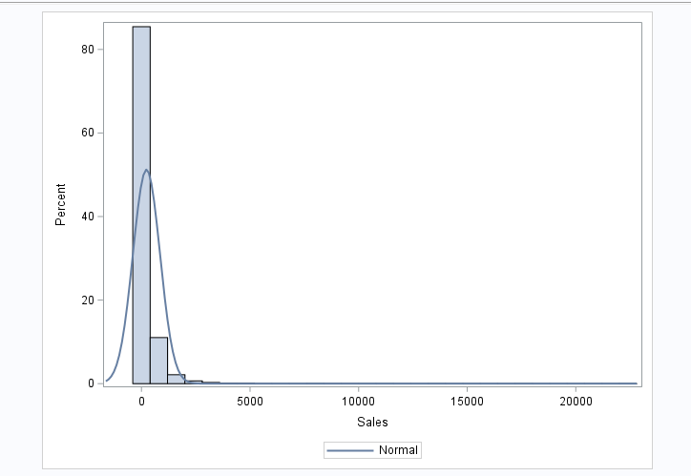

Right skewed: Can be easily interpreted graphically, through the density curve as it has large tail on the right side of the data as well as through the value of skewness which is 12.97, (positive) which indicates that the mean is shifted to the right side of the data and outliers exist in the right side of the data.
Kurtosis is very high (305.31) which is not in the threshold of (-3,3) that indicates existence of potential outliers.
Data is not normal as the values of mean and median are very different mean is 229.85 while median is 54.49
Discount
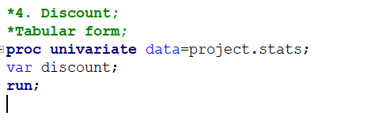
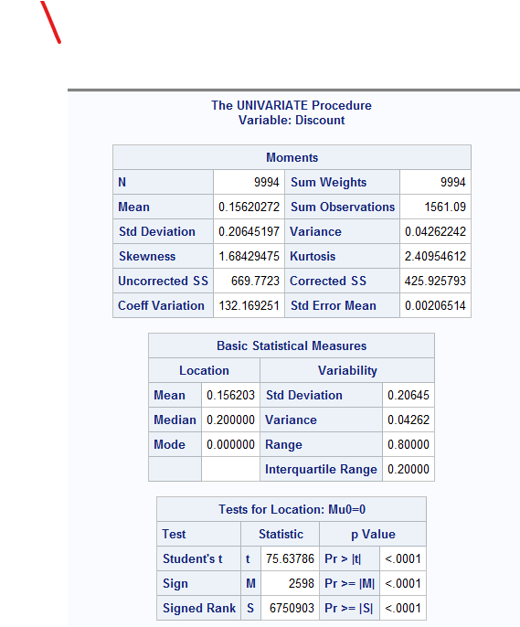
Skewness value is 1.68 which is positively skewed (right skewed) that means possibility of outliers in right side of the data.
Kurtosis value (2.40) is between threshold value that is (-3,3) which indicates possibility of outliers.
Data is not normal as the values of mean (0.15) and median (0.20) are not similar.
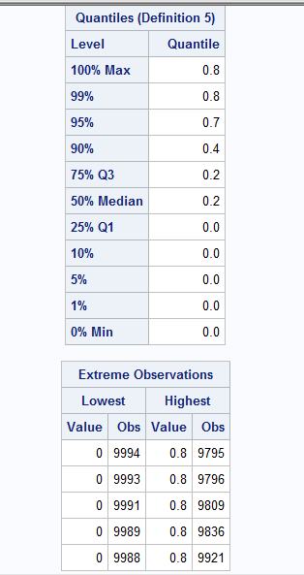

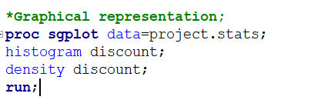
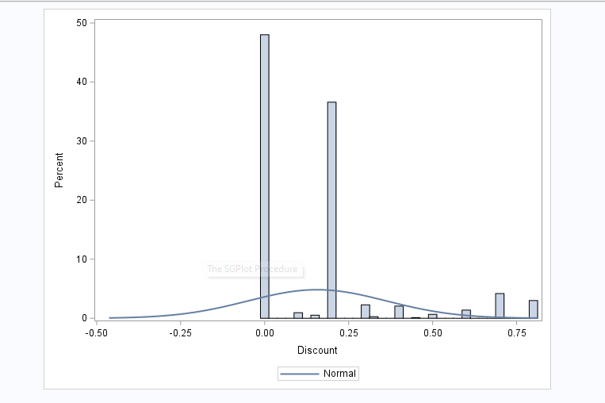

Bivariate analysis:
Numerical variables: Correlation and regression modelling
Correlation between all the numerical variables through graphical and tabular form.
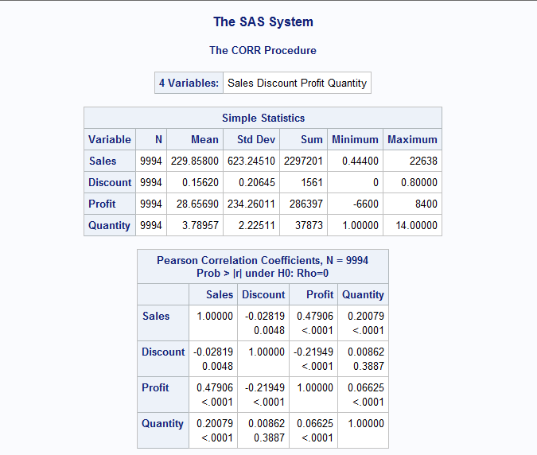

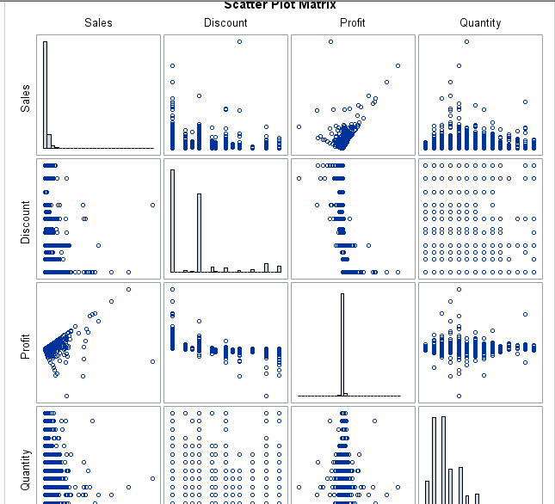

Prediction of correlation through:
- R (coefficient of correlation):
0.5 ≤ |r| → High linear correlation
0.3 ≤ |r| < 0.5 → Medium linear correlation
0 ≤ |r| < 0.3 → Low linear correlation
r=0➔no linear correlation
r= +1 or -1➔perfect linear relationship
- P-value: P-value is more than 5% than we fail to reject null hypothesis (R=0) otherwise we accept alternative hypothesis.

Sales-Discount: (have low correlation)

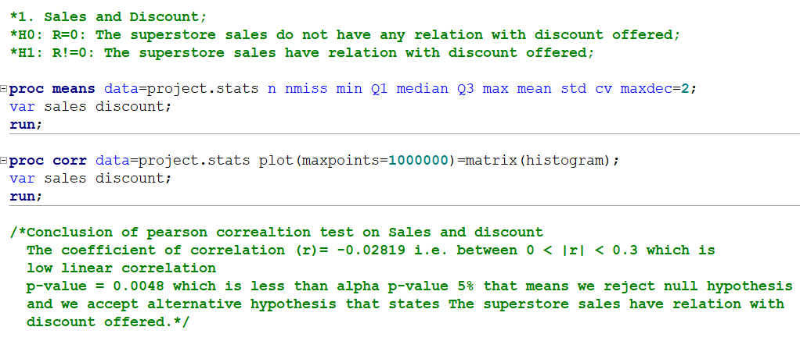
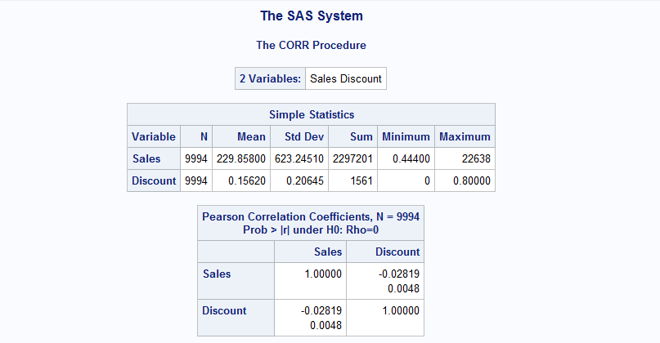

R= -0.028 which is negative and low linear correlation
P-value=0.0048 which is less than 5% (accepts alternative H)

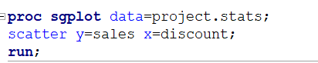
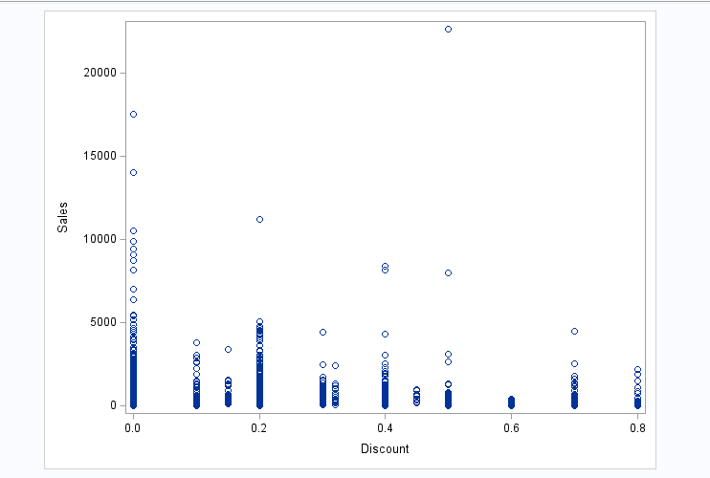

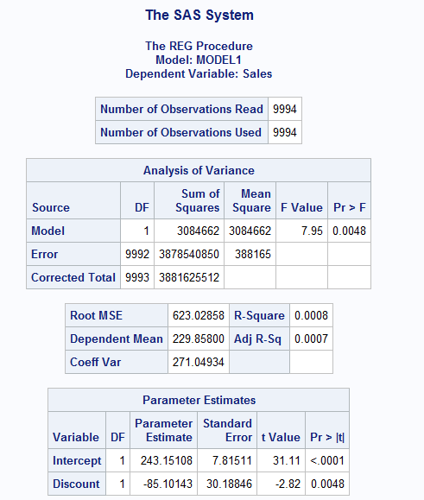

Conclusion:
R-squared value is 0.2295 which is between
0 and 1 i.e., the model explains 22.95% of
Variance which is very less and is not a good fit.
Adjusted R-Squared value is 0.2294 which is similar to the r-squared value indicating that
22.94% of variance.

Sales-Profit: (have medium correlation)
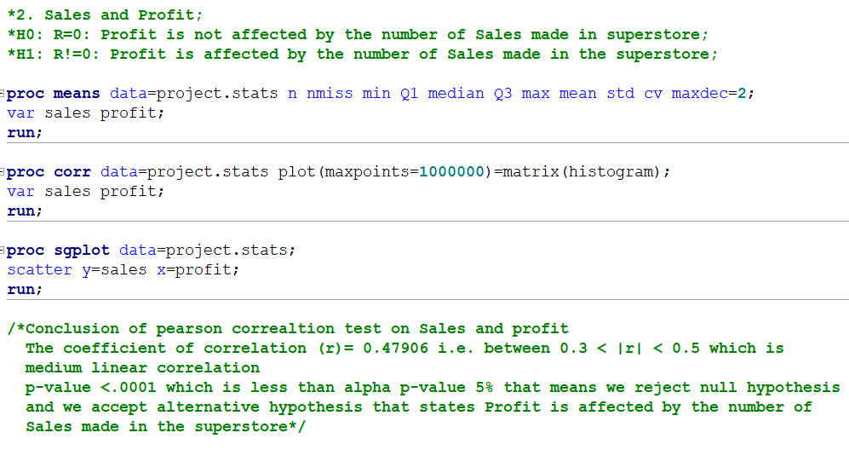
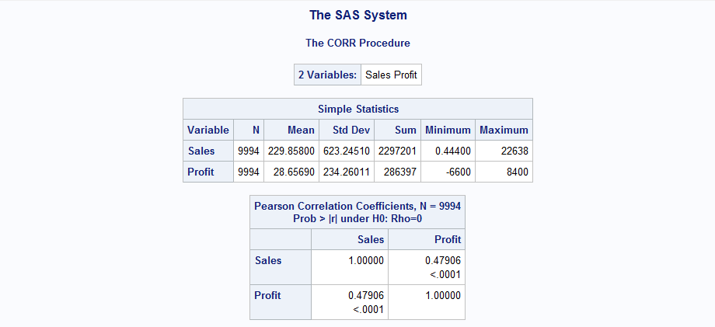

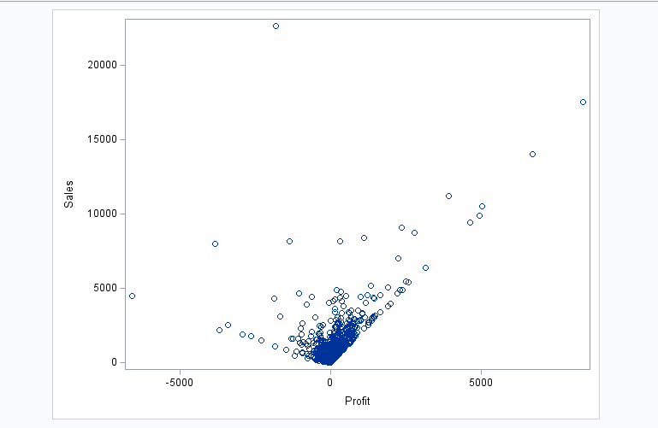
R=0.47 which is medium positive linear correlation
p-Value < 0.0001 that is less than 5%, we reject null hypothesis.

Sales-Quantity: (low positive linear correlation)

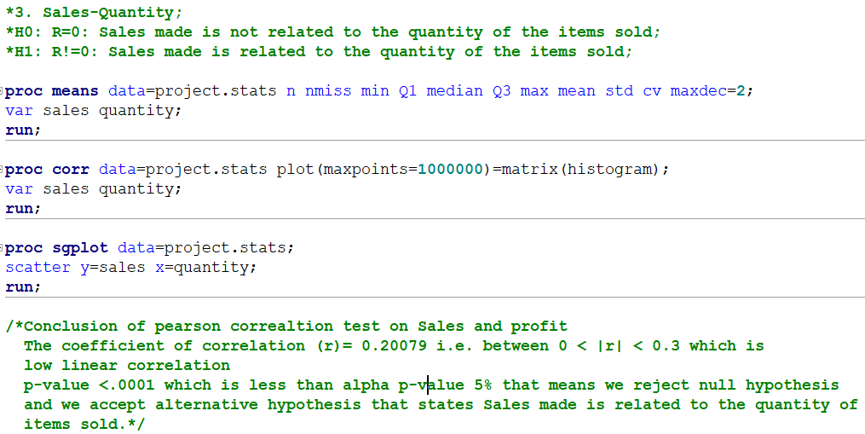
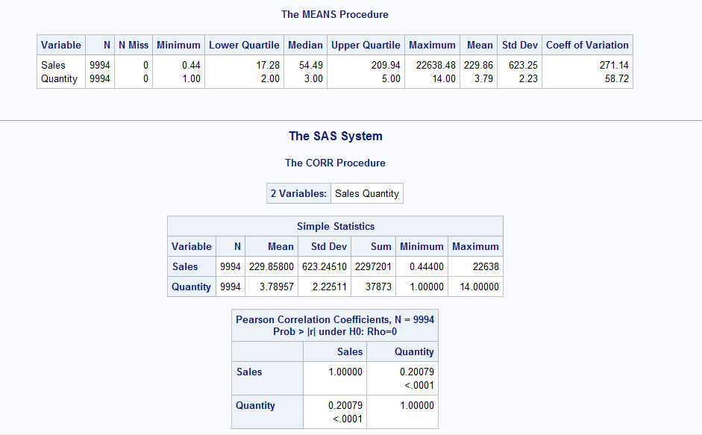

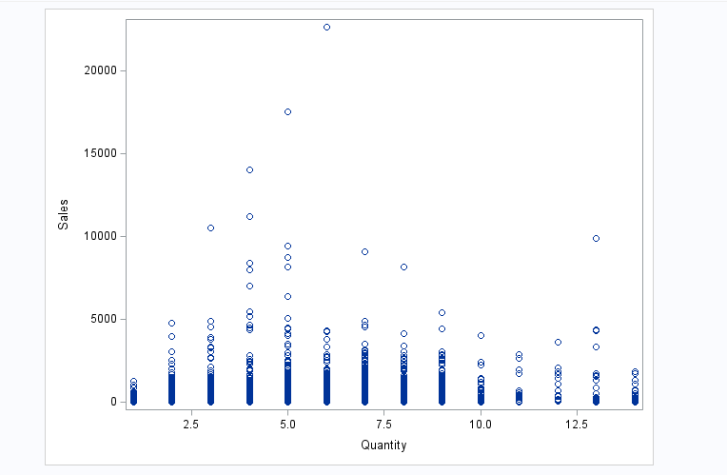

R=0.20 which is low positive correlation
p-value<0.0001 that is less than 5%, we reject null hypothesis.

Discount-Profit: (low negative linear correlation)

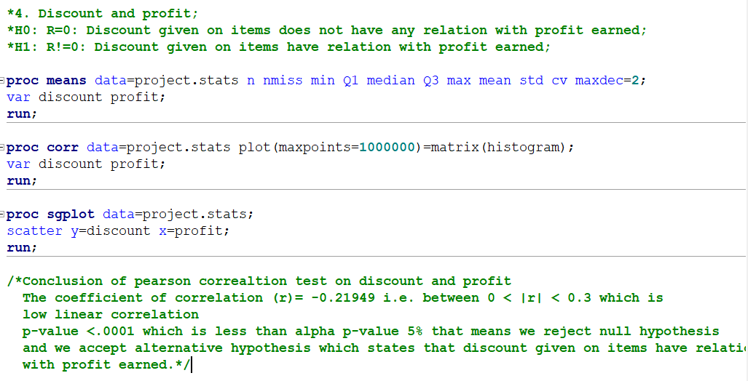

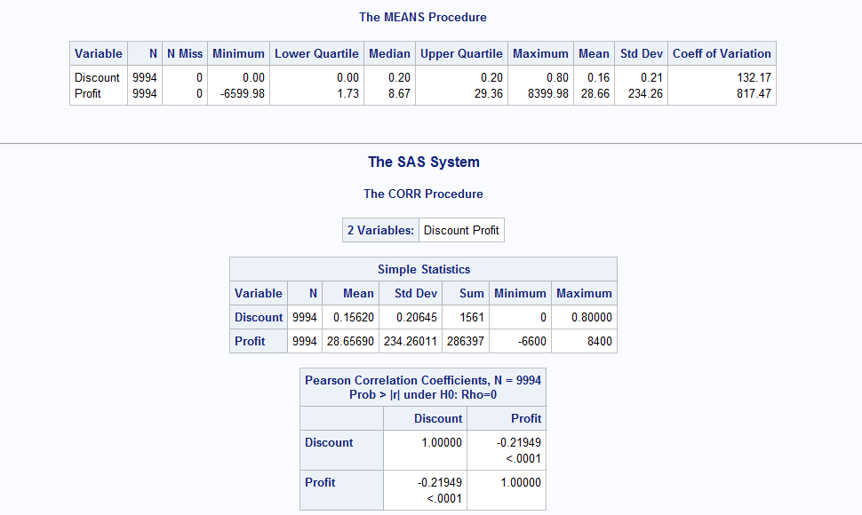

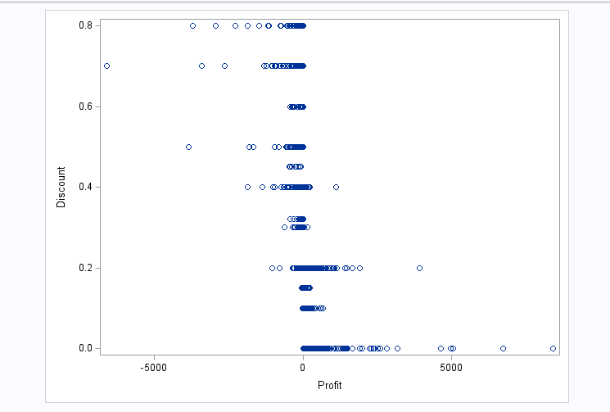

R= -0.21 which is negative low linear correlation
p-value<0.0001 that is less than 5%, we reject null hypothesis.

Discount-Quantity: (no correlation)
R=0.0086, low linear correlation
p-value=0.38 which is more than 0.05, we fail to reject null hypothesis that means we accept null hypothesis which is no correlation.

Profit-Quantity: (low positive linear correlation)

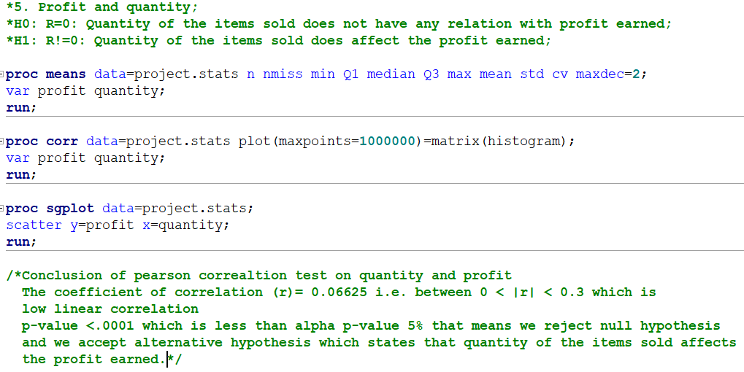

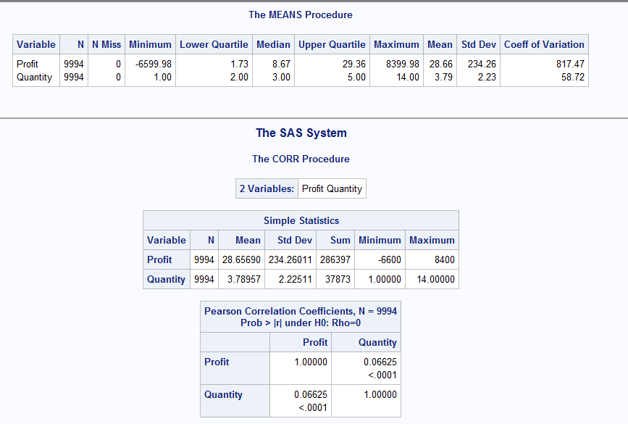

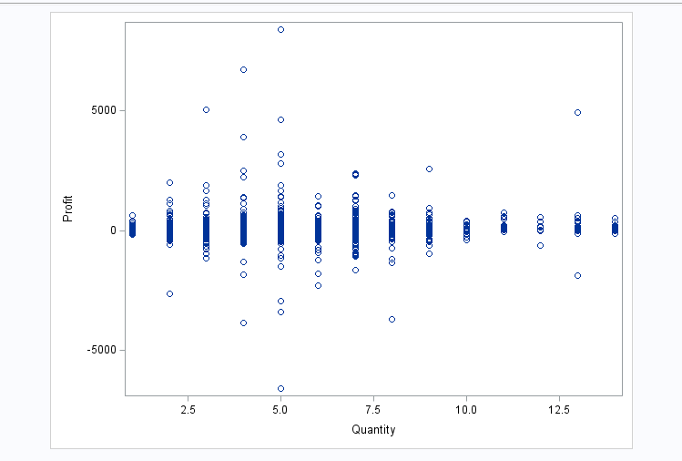

R=0.066, low positive correlation
p-value<0.0001, less than 5%, accepts alternative hypothesis.

Categorical*Categorical

- Segment*Shipment_mode;
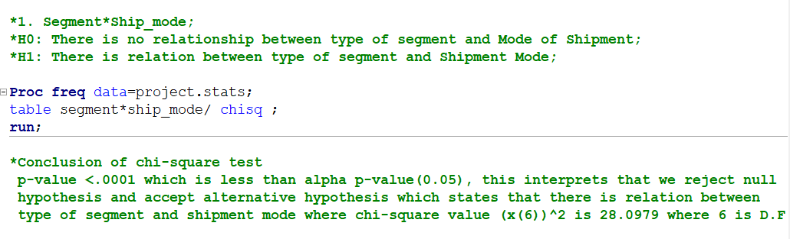
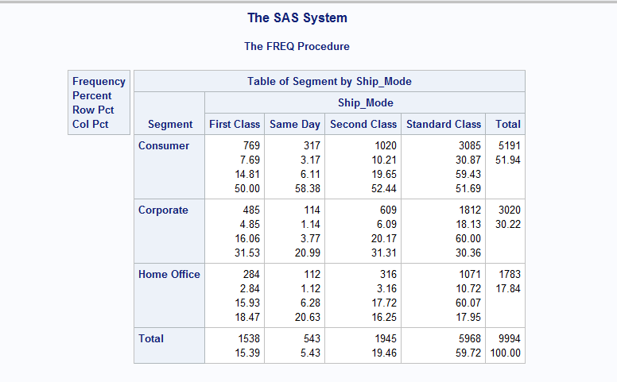
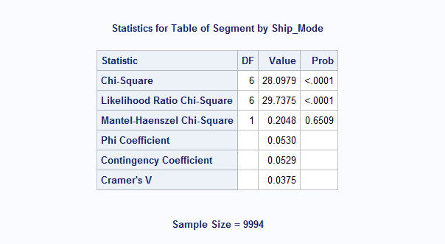

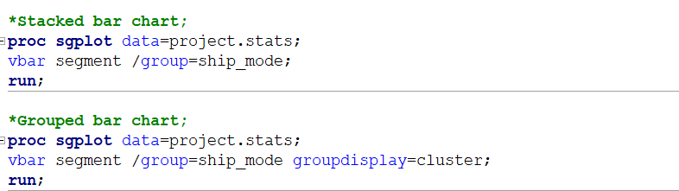
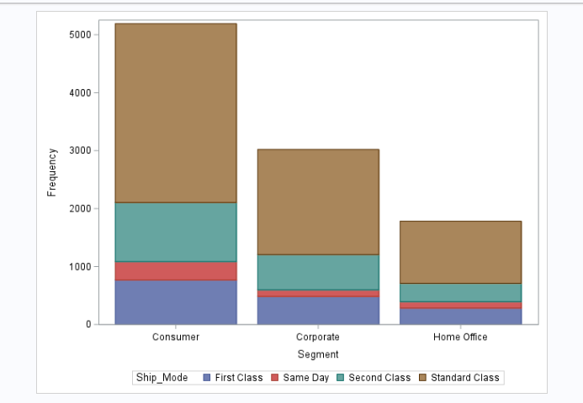

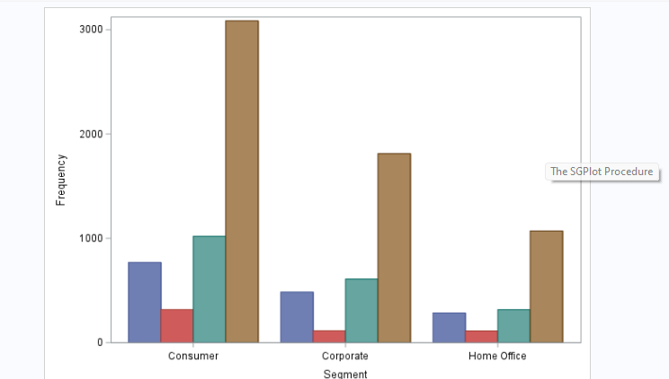

- Segment*State
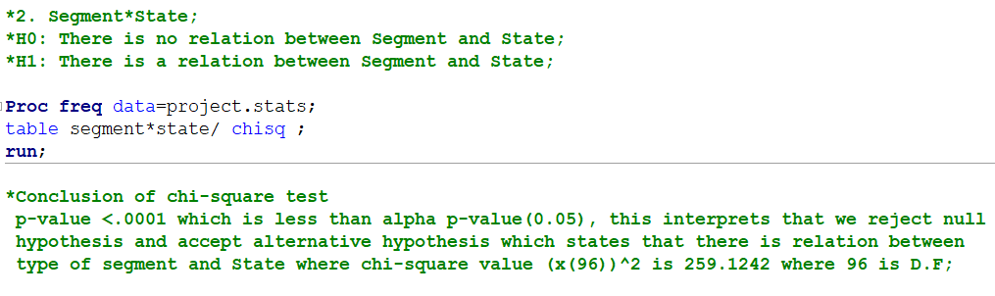
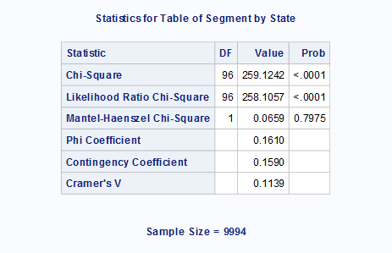
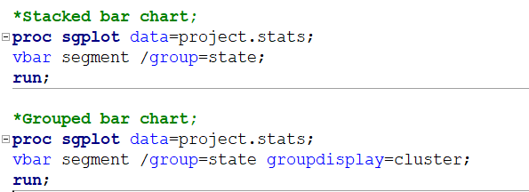
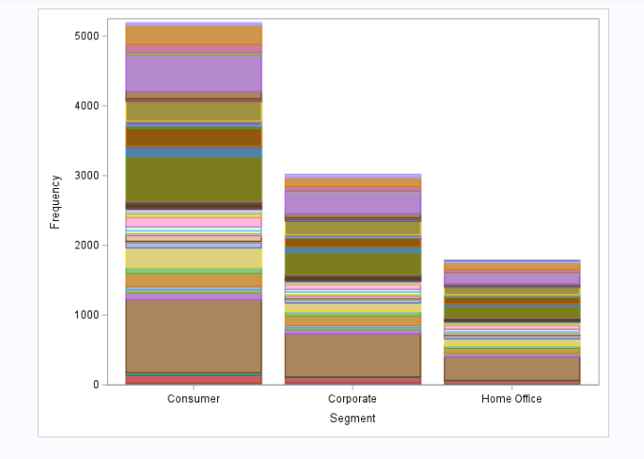

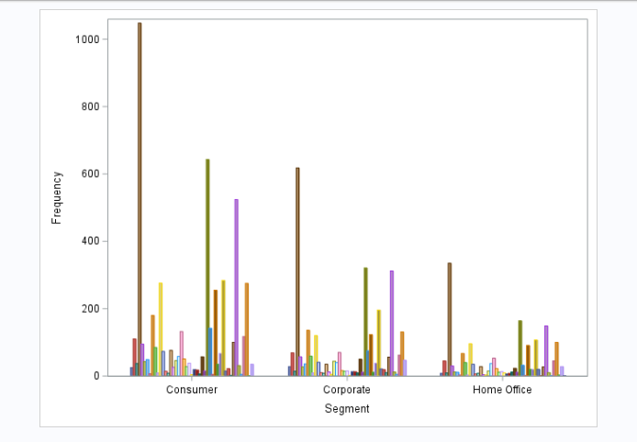
Categorical (more than 2 levels) * Numerical
ANOVA TEST

1.SALES * SEGMENT

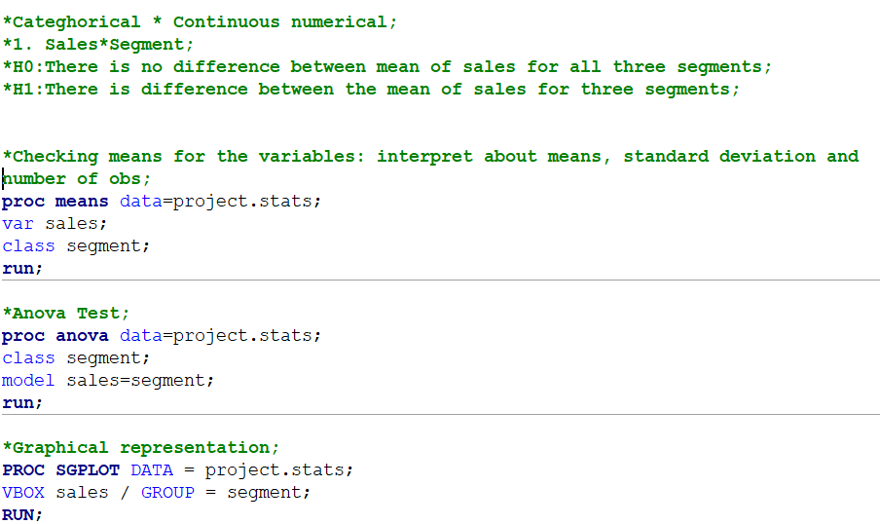

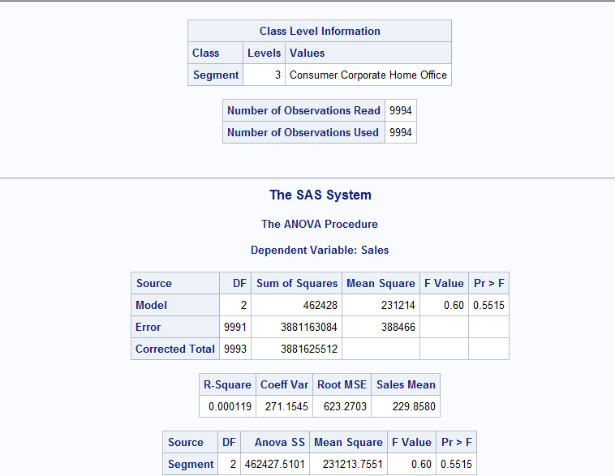

Conclusion based on ANOVA test:
F Value: The overall F-statistic of the ANOVA model.
This is calculated as Mean Square Model / Mean Square Error, which is 0.60.
Pr >F: The most important value in the entire output is the p-value because this tells us whether there is a significant difference in the mean profit between the three groups.
The P-value of the F-test is 0.5515 which is MORE than the alpha P-value 0.05, that
indicates that we fail to reject null hypothesis that means the difference between the mean
of sales for different levels of segment is not statistically significant.

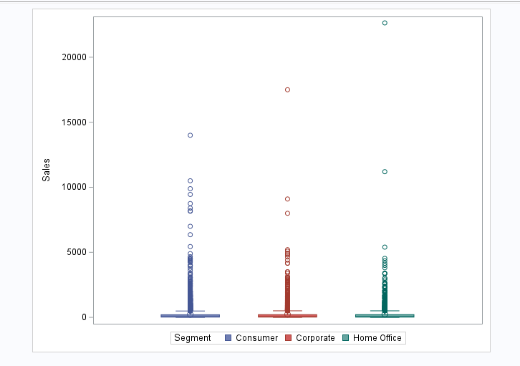

2.PROFIT * CATEGORY

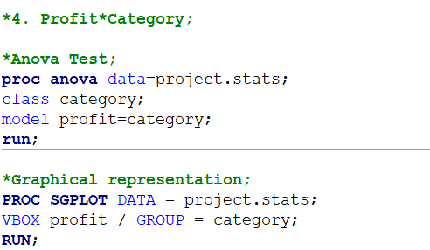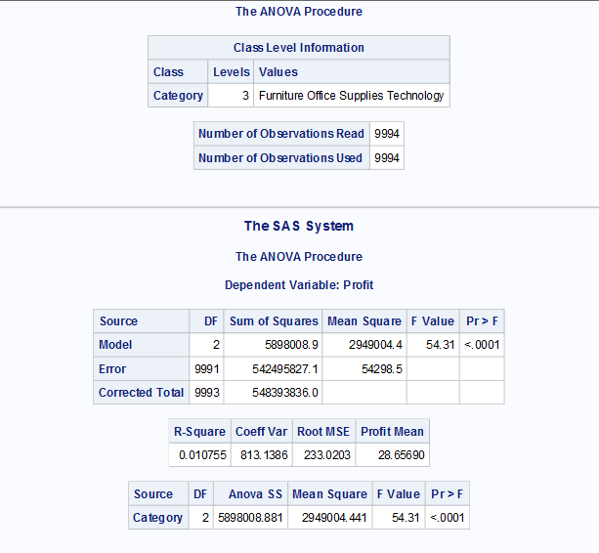
Model is variance explained by the independent variable
Error is the variance that is not explained by the model.
- Model DF is (levels-1)=3-1=2
- Error DF is Total_obs-levels=9994-3=9991
- Corrected DF Total_obs-1=9994-1=9993
- Sum of squares for model explains variance represented by model i.e., 5898008.9
- Sum of squares for error explains variance that is not explained by variable i.e., 542495827.1
- Mean Square of model = 5898008.9 / 2 = 2949004.4
- Mean Square of Error = 542495827.1 / 9991 = 54298.5
- F-value=Mean Square of Model / Mean square of error=54.31
- P-value is <0.0001 less than alpha P-value that is 0.05, strong evidence against null hypothesis, reject null hypothesis.
- R-squared is 0.010755 which means 1.07% of variance in profit explains the model, which is very less that means relatively low fit of the model to the data.
- Coff of Variance (C.V.) 813.1386 explains the relative variability of profit with respect to its means (standardize the S.D. of variable)
- Root MSE (Mean Square Error) 233.0202 explains the standard deviation of the residuals, prediction errors(how well model’s prediction match the data)
Mean of profit is 28.656590 across the observations.
Conclusion based on ANOVA test:
F Value: The overall F-statistic of the ANOVA model.
This is calculated as Mean Square Model / Mean Square Error, which is 54.31.
Pr >F: The most important value in the entire output is the p-value because this tells us whether there is a significant difference in the mean profit between the three groups.
The P-value of the F-test is <0.0001 which is less than the alpha P-value 0.05, that
indicates that we reject null hypothesis and accept the alternative hypothesis
which states that the difference between the mean of profit for different levels of categories is statistically significant.
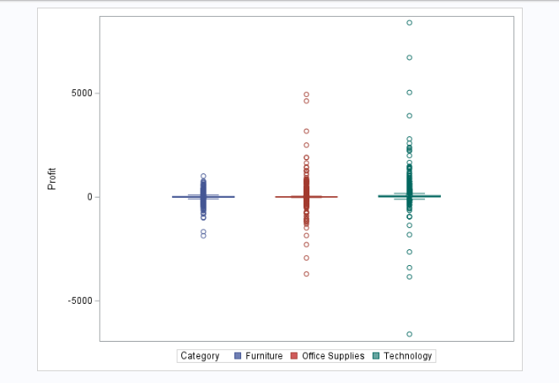

MULTIVARIATE ANALYSIS
PROFIT * CATEGORY * SALES

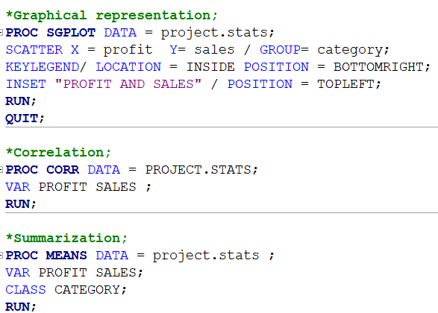
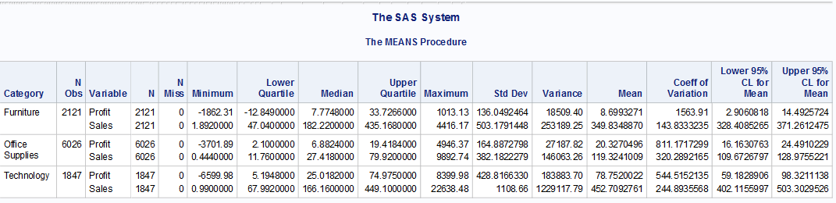

The proc means table explains about the relation between category levels with sales and profit which states
Total observation are 9994 with
Average profit for Furniture between [2.90608,14.4925] with a confidence level of 95%
Average profit for Office supplies between [16.16,24.49] with a confidence level of 95%
Average profit for Technology between [59.18,98.32] with a confidence level of 95%

Average Sales for Furniture between [328.40,371.26] with a confidence level of 95%
Average Sales for Office supplies between [109.57,128.97] with a confidence level of 95%
Average Sales for Technology between [402.11,503.302] with a confidence level of 95%

